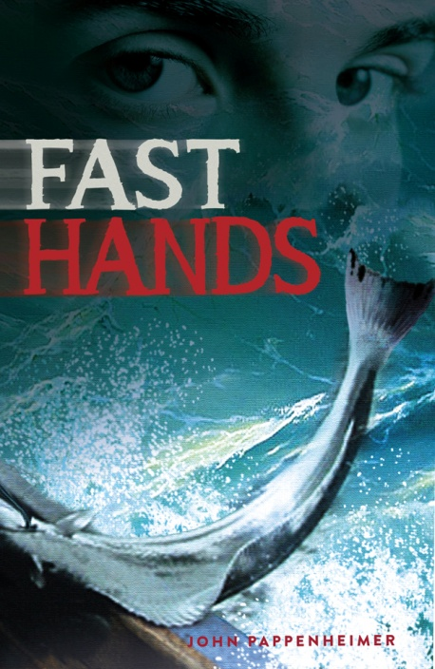
New from Epicenter Press May, 2014
Fast Hands
John Pappenheimer
A troubled teen-ager grows up fast on an Alaska fishing boat.

YOUNG ADULT FICTION
184 pages, 5.25 x 8
Trade paperback
$12.95 978-1-935347-31-6
(Distributed by Epicenter Press)
Publication date: May, 2014

STORY: An adventure story off the coast of Alaska as told by a troubled teenager. Inspired by true stories of young people suddenly plunked down into a world for which they were not prepared. Sixteen-year-old Gus Pedersen has to grow up fast, facing down his fears and keeping up with grown men long accustom to hard, dangerous work. On shore he faces another set of challenges. He must avoid a bully off a neighboring seine boat. He must deal with a crush on a 19-year-old woman with troubles of her own and he must figure out how to end a curse that has split apart his family.

ENDORSEMENTS FOR FAST HANDS
“Tough love, teen romance, and the rough side of Southeast Alaska make for a satisfying coming-of-age tale” – Joe Upton, author, Alaska Blues
“This fast-paced story proves the adage ‘It takes a village.’ The characters and events nudge a struggling teenager towards manhood in this gripping read.”
—Marcy Stewart, former children’s librarian, Ketchikan Public Library
“As an accordion playing child of a Norwegian halibut fisherman from the Lofotens, and as a school librarian, I was very
much engaged by Fast Hands, and I would recommend it for school and public libraries. It is all there: the Alaska fishing experience (even White Sulpher Hotsprings!) and an insightful description of teenage maturation. -- Suzanne Paulsen, Petersburg, AK

“The novel is terrific. One of the best reads I’ve had in a while, and I’m not even a kid.” —Roger Fitzgerald, National Fisherman

SELLING POINTS:
- Author has extensive knowledge of halibut fishing having skippered a longliner in the 1970s. As publisher of the Alaska Fisherman’s Journal for over 20 years, he has collected a wealth of stories from the fishing grounds.

- A timely addition to libraries now that the states Alaska Maritime Workforce Development Plan has set among its goals “Coordinated training between K-12 educators, regional training centers, and the University of Alaska is needed to prepare high school students for additional training or work in the maritime sector… .”

ABOUT THE AUTHOR: John Pappenheimer was a reporter for the Baltimore Evening Sun in the late 60s. He went on to run fishing boats in Southeast Alaska and to launch the magazines Alaska Fisherman’s Journal, Seafood Leader and Simply Seafood.

Distributed by Epicenter Press Available from major wholesalers
For review copies & publicity information, visit www.EpicenterPress.com
To read sample pages go to www.EpicenterPress.com/book7316.html

